Burundi

## Population Data

The data set shows the political stability estimate of the country each year.

## # A tibble: 23 x 5  
## country iso3c date population popCategory5  
## <chr> <chr> <dbl> <dbl> <chr>   
## 1 Burundi BDI 1996 6060111 small   
## 2 Burundi BDI 1997 6122130 small   
## 3 Burundi BDI 1998 6185562 small   
## 4 Burundi BDI 1999 6267124 small   
## 5 Burundi BDI 2000 6378871 small   
## 6 Burundi BDI 2001 6525545 small   
## 7 Burundi BDI 2002 6704113 small   
## 8 Burundi BDI 2003 6909154 small   
## 9 Burundi BDI 2004 7131693 small   
## 10 Burundi BDI 2005 7364862 small   
## 11 Burundi BDI 2006 7607849 small   
## 12 Burundi BDI 2007 7862214 small   
## 13 Burundi BDI 2008 8126102 small   
## 14 Burundi BDI 2009 8397668 small   
## 15 Burundi BDI 2010 8675602 small   
## 16 Burundi BDI 2011 8958406 small   
## 17 Burundi BDI 2012 9245988 small   
## 18 Burundi BDI 2013 9540289 small   
## 19 Burundi BDI 2014 9844297 small   
## 20 Burundi BDI 2015 10160030 small   
## 21 Burundi BDI 2016 10487998 small   
## 22 Burundi BDI 2017 10827024 small   
## 23 Burundi BDI 2018 11175378 small

## # A tibble: 23 x 5  
## country iso3c date popGrowth popGrowthCat5   
## <chr> <chr> <dbl> <dbl> <chr>   
## 1 Burundi BDI 1996 1.21 slow growth rate   
## 2 Burundi BDI 1997 1.02 slow growth rate   
## 3 Burundi BDI 1998 1.03 slow growth rate   
## 4 Burundi BDI 1999 1.31 slow growth rate   
## 5 Burundi BDI 2000 1.77 moderate growth rate  
## 6 Burundi BDI 2001 2.27 moderate growth rate  
## 7 Burundi BDI 2002 2.70 high growth rate   
## 8 Burundi BDI 2003 3.01 high growth rate   
## 9 Burundi BDI 2004 3.17 high growth rate   
## 10 Burundi BDI 2005 3.22 high growth rate   
## 11 Burundi BDI 2006 3.25 high growth rate   
## 12 Burundi BDI 2007 3.29 high growth rate   
## 13 Burundi BDI 2008 3.30 high growth rate   
## 14 Burundi BDI 2009 3.29 high growth rate   
## 15 Burundi BDI 2010 3.26 high growth rate   
## 16 Burundi BDI 2011 3.21 high growth rate   
## 17 Burundi BDI 2012 3.16 high growth rate   
## 18 Burundi BDI 2013 3.13 high growth rate   
## 19 Burundi BDI 2014 3.14 high growth rate   
## 20 Burundi BDI 2015 3.16 high growth rate   
## 21 Burundi BDI 2016 3.18 high growth rate   
## 22 Burundi BDI 2017 3.18 high growth rate   
## 23 Burundi BDI 2018 3.17 high growth rate

## Population trend

The plot shows the population trend of the country.

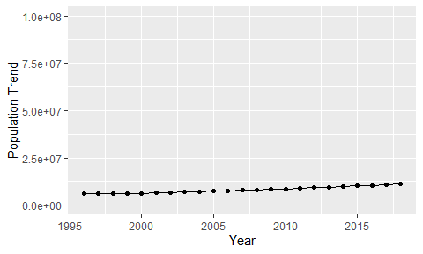

Political Stability Trend

# Population growth graph

The plot shows the population growth rate trend of the country.

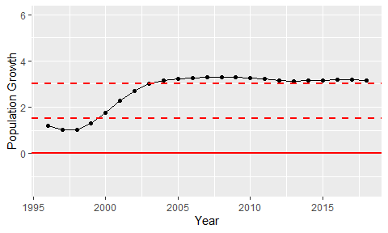

Population Growth Trend